

See discussions, stats, and author profiles for this publication at: [https://www.researchgate.net/publication/334051387](https://www.researchgate.net/publication/334051387_Deep_Face_Recognition_for_Biometric_Authentication?enrichId=rgreq-2a19e6ee74be07a6bd2685fb870670b3-XXX&enrichSource=Y292ZXJQYWdlOzMzNDA1MTM4NztBUzo3OTYzNjAxMDYzMjgwNjlAMTU2Njg3ODQ1Mzg3Mg%3D%3D&el=1_x_2&_esc=publicationCoverPdf)

[Deep Face Recognition for Biometric Authentication](https://www.researchgate.net/publication/334051387_Deep_Face_Recognition_for_Biometric_Authentication?enrichId=rgreq-2a19e6ee74be07a6bd2685fb870670b3-XXX&enrichSource=Y292ZXJQYWdlOzMzNDA1MTM4NztBUzo3OTYzNjAxMDYzMjgwNjlAMTU2Njg3ODQ1Mzg3Mg%3D%3D&el=1_x_3&_esc=publicationCoverPdf)

**Conference Paper** · July 2019

DOI: 10.1109/ICECCE47252.2019.8940725

CITATIONS

0

READS

833

**4 authors**, including:

[Maheen Zulfiqar](https://www.researchgate.net/profile/Maheen_Zulfiqar?enrichId=rgreq-2a19e6ee74be07a6bd2685fb870670b3-XXX&enrichSource=Y292ZXJQYWdlOzMzNDA1MTM4NztBUzo3OTYzNjAxMDYzMjgwNjlAMTU2Njg3ODQ1Mzg3Mg%3D%3D&el=1_x_5&_esc=publicationCoverPdf)

[Institute of Space Technology](https://www.researchgate.net/institution/Institute_of_Space_Technology?enrichId=rgreq-2a19e6ee74be07a6bd2685fb870670b3-XXX&enrichSource=Y292ZXJQYWdlOzMzNDA1MTM4NztBUzo3OTYzNjAxMDYzMjgwNjlAMTU2Njg3ODQ1Mzg3Mg%3D%3D&el=1_x_6&_esc=publicationCoverPdf)

**1** PUBLICATION **0** CITATIONS

[Muhammad Jaleed Khan](https://www.researchgate.net/profile/Muhammad_Khan942?enrichId=rgreq-2a19e6ee74be07a6bd2685fb870670b3-XXX&enrichSource=Y292ZXJQYWdlOzMzNDA1MTM4NztBUzo3OTYzNjAxMDYzMjgwNjlAMTU2Njg3ODQ1Mzg3Mg%3D%3D&el=1_x_5&_esc=publicationCoverPdf)

[National University of Ireland, Galway](https://www.researchgate.net/institution/National_University_of_Ireland_Galway?enrichId=rgreq-2a19e6ee74be07a6bd2685fb870670b3-XXX&enrichSource=Y292ZXJQYWdlOzMzNDA1MTM4NztBUzo3OTYzNjAxMDYzMjgwNjlAMTU2Njg3ODQ1Mzg3Mg%3D%3D&el=1_x_6&_esc=publicationCoverPdf)

**25** PUBLICATIONS **151** CITATIONS

[SEE PROFILE](https://www.researchgate.net/profile/Maheen_Zulfiqar?enrichId=rgreq-2a19e6ee74be07a6bd2685fb870670b3-XXX&enrichSource=Y292ZXJQYWdlOzMzNDA1MTM4NztBUzo3OTYzNjAxMDYzMjgwNjlAMTU2Njg3ODQ1Mzg3Mg%3D%3D&el=1_x_7&_esc=publicationCoverPdf)

[SEE PROFILE](https://www.researchgate.net/profile/Muhammad_Khan942?enrichId=rgreq-2a19e6ee74be07a6bd2685fb870670b3-XXX&enrichSource=Y292ZXJQYWdlOzMzNDA1MTM4NztBUzo3OTYzNjAxMDYzMjgwNjlAMTU2Njg3ODQ1Mzg3Mg%3D%3D&el=1_x_7&_esc=publicationCoverPdf)

[Khurram Khurshid](https://www.researchgate.net/profile/Khurram_Khurshid2?enrichId=rgreq-2a19e6ee74be07a6bd2685fb870670b3-XXX&enrichSource=Y292ZXJQYWdlOzMzNDA1MTM4NztBUzo3OTYzNjAxMDYzMjgwNjlAMTU2Njg3ODQ1Mzg3Mg%3D%3D&el=1_x_5&_esc=publicationCoverPdf)

[Institute of Space Technology](https://www.researchgate.net/institution/Institute_of_Space_Technology?enrichId=rgreq-2a19e6ee74be07a6bd2685fb870670b3-XXX&enrichSource=Y292ZXJQYWdlOzMzNDA1MTM4NztBUzo3OTYzNjAxMDYzMjgwNjlAMTU2Njg3ODQ1Mzg3Mg%3D%3D&el=1_x_6&_esc=publicationCoverPdf)

**102** PUBLICATIONS **668** CITATIONS

[SEE PROFILE](https://www.researchgate.net/profile/Khurram_Khurshid2?enrichId=rgreq-2a19e6ee74be07a6bd2685fb870670b3-XXX&enrichSource=Y292ZXJQYWdlOzMzNDA1MTM4NztBUzo3OTYzNjAxMDYzMjgwNjlAMTU2Njg3ODQ1Mzg3Mg%3D%3D&el=1_x_7&_esc=publicationCoverPdf)

**Some of the authors of this publication are also working on these related projects:**

Small Satellite Design and Development [View project](https://www.researchgate.net/project/Small-Satellite-Design-and-Development?enrichId=rgreq-2a19e6ee74be07a6bd2685fb870670b3-XXX&enrichSource=Y292ZXJQYWdlOzMzNDA1MTM4NztBUzo3OTYzNjAxMDYzMjgwNjlAMTU2Njg3ODQ1Mzg3Mg%3D%3D&el=1_x_9&_esc=publicationCoverPdf)



Quantum Machine Learning Paradigm for future generation mobile networks [View project](https://www.researchgate.net/project/Quantum-Machine-Learning-Paradigm-for-future-generation-mobile-networks?enrichId=rgreq-2a19e6ee74be07a6bd2685fb870670b3-XXX&enrichSource=Y292ZXJQYWdlOzMzNDA1MTM4NztBUzo3OTYzNjAxMDYzMjgwNjlAMTU2Njg3ODQ1Mzg3Mg%3D%3D&el=1_x_9&_esc=publicationCoverPdf)

All content following this page was uploaded by [Khurram Khurshid](https://www.researchgate.net/profile/Khurram_Khurshid2?enrichId=rgreq-2a19e6ee74be07a6bd2685fb870670b3-XXX&enrichSource=Y292ZXJQYWdlOzMzNDA1MTM4NztBUzo3OTYzNjAxMDYzMjgwNjlAMTU2Njg3ODQ1Mzg3Mg%3D%3D&el=1_x_10&_esc=publicationCoverPdf) on 27 August 2019.

The user has requested enhancement of the downloaded file.

Deep Face Recognition for Biometric Authentication

Maheen Zulfiqar *Department of Electrcial Engineering*

*Institute of Space Technology* Islamabad, Pakistan [maheenzulfiqar89@gmail.com](mailto:maheenzulfiqar89@gmail.com)

Fatima Syed *Department of Electrcial Engineering*

*Institute of Space Technology* Islamabad, Pakistan [fatima17pk@gmail.com](mailto:fatima17pk@gmail.com)

Muhammad Jaleed Khan *iVision Lab, Department of Electrcial Engineering*

*Institute of Space Technology* Islamabad, Pakistan [mjk093@gmail.com](mailto:mjk093@gmail.com)

Khurram Khurshid *iVision Lab, Department of Electrcial Engineering*

*Institute of Space Technology* Islamabad, Pakistan [khurram.khurshid@ist.edu.pk](mailto:khurram.khurshid@ist.edu.pk)

***Abstract***—**Face is one of the most widely used biometrics for human identity authentication. Facial recognition has remained an interesting and active research area in the past several decades due to its ever growing applications in biometric authentication, content based data retrieval, video surveillance, access control and social media. Unlike other biometric systems, facial recognition based systems work independently without involving the individual, due to which it does not add unnecessary delay. Its ability of recognizing multiple persons at a time further adds to its speed. There are many face recognition methods based on traditional machine learning that are available in the literature. Improvements are being made with the constant developments in computer vision and machine learning. However, most of the traditional methods lack robustness against varying illumination, facial expression, scale, occlusions and pose. With the advent of big data and graphical computing, deep learning has impressively advanced the traditional computer vision systems over the past decade. In this paper, we present a convolutional neural network based face recognition system which detects faces in an input image using Viola Jones face detector and automatically extracts facial features from detected faces using a pre-trained CNN for recognition. A large database of facial images of subjects is created, which is augmented in order to increase the number of images per subject and to incorporate different illumination and noise conditions for optimal training of the convolutional neural network. Moreover, an optimal pretrained CNN model along with a set of hyperparameters is experimentally selected for deep face recognition. Promising experimental results, with an overall accuracy of 98.76%, are obtained which depict the effectiveness of deep face recognition in automated biometric authentication systems.**

***Keywords—*Face recognition, Viola Jones face detection, deep learning, convolutional neural network, biometric authentication.**

1. INTRODUCTION

Face is considered to be the most important part of human body. It plays a vital role in identification and authentication of a person, due to which it can be used for numerous daily life applications. Facial recognition systems are gaining importance day by day. Once it was thought to be limited to fictitious movies only as it seemed difficult to detect a person and recognizing. Now a lot of work has been done in this area. Facial recognition system is trending around the globe as it provides secure and reliable security solutions. It is the fastest biometric technology that identifies a person without involving that person. It does not add any unwanted delay as it automatically captures the image of a person from a certain distance or take a frame from a video stream, processes that image and recognizes that person. Other biometric technologies

such as fingerprint reader, eye scanner and voice recognizer involves human activity and adds significant delays. To overcome these problems, automatic facial recognition systems are widely used which does not require any human interaction for identification [1]. Facial recognition systems play an important role in crime deterrence in offices, colleges and universities and residential buildings and corporate organizations. In schools and universities, it can be effectively used for automatic attendance management to save time and minimize the possibility of wrong attendance [2]. Similarly, it can be used in conferences and public events where a large number of people are dealt in short durations of time at entry and exit points. It is also used to enforce controlled access to restricted areas. Any individual breaching the entrance rule can be spotted and an alert can be triggered. Besides its numerous applications and complimentary properties, there are some major problems associated with facial recognition which limits its effectiveness in practical scenarios [3]:

1. Processing speed and storage: Facial recognition systems require huge amount of storage space for storage of huge amount of data for processing. Cluster computing is used by professional agencies to minimize total processing time and servers are used for huge data storage, which are very costly.
2. Image size and quality: The performance of person identification highly depends on the quality of facial images. The traditional methods require input images to have size comparable to those available in the dataset for accurate recognition, however facial images drastically vary in daily life scenarios.
3. Surveillance angle: The identification of a person depends upon surveillance angle if the method is not robust to translations and rotations. The traditional methods require input images to have facial orientation comparable to those available in the dataset which are probably frontal images, which is mostly not the case in practical scenes.
4. Light variations: The intensity variations in images due to varying illumination makes facial recognition more complex. Optimal lightening conditions are necessary for accurate identification in traditional methods.
5. Inter-class variability: As the number of people in a database increases, the accuracy eventually tends to decrease if proper measures are not taken. Many people have resemblance and this resemblance makes identification difficult and results to false positives and false negatives during classification [4], which adversely affects the performance of biometric verification systems.

There is a constant need for development of accurate and robust facial recognition systems which can perform effectively in spite of the above mentioned challenging scenarios. In this paper, we propose a deep learning based automated facial recognition system for biometric authentication systems. Convolutional neural network (CNN), which is invariant to varying scale, shift, rotation and illumination, has the capability to mitigate the practical challenges characterized by face recognition [6]. The large training time of CNN is reduced by using pre-trained CNNs and transfer learning. An optimal pretrained CNN model along with a set of hyperparameters is experimentally selected for deep face recognition. Furthermore, captured images in the dataset are augmented and different challenging conditions such as image transformations and brightness variations are incorporated for a comprehensive experimental evaluation.

The remaining paper is organized as follows: Section II provides a detailed overview of the existing methods used for face recognition. Section III presents the proposed deep learning based face recognition system. Section IV presents the experimental results and research findings in detail, which is followed by the conclusion and future prospects of deep face recognition based biometric authentication in Section V.

1. LITERATURE REVIEW

Face is considered as one of the most important biometrics used for authentication and identification in a wide variety of applications. Other biometrics include fingerprint, iris, signature, ink and handwritten text [35-44]. Face recognition is the most researched topics in computer vision and machine learning since 1970s. A lot of efforts have been made to develop facial recognition systems more robust and reliable. The traditional methods were subject to hand-crafted techniques like edges and contours [5], which have been used for face classification for a long time. Recently, the trend towards replacing the traditional methods by deep learning methods is increasing. Convolutional Neural Network (CNN) is a widely used deep learning method for image classification and object recognition. Deep learning based automated facial recognition systems have high potential in improving its current applications including biometric authentication, content based data retrieval, video surveillance, access control and social media [7]. The traditional methods and state of the art methods for facial recognitions are categorically discussed in the following subsections.

1. *Geometry based methods*

Geometric features based methods were initially used for automatic face recognition in early seventies. These methods depends upon specialized edges and contours of the face, from which the facial landmarks were detected and then their position and distance was measured. In [8], the facial image is transformed into geometric primitives and distinctive features such as eyes, nose and mouth are located and their position is noted. This produced accurate results but it was designed for very small dataset, containing 10 subjects. Appearance based features are employed in the method proposed in [9] that registers the statistical pixel values of facial image and compare them. Geometry based method is fast and occupies less storage as compare to appearance based method.

1. *Holistic methods*

In holistic methods, faces are represented as 2-D matrices rather than a 3-D geometry. It decomposes an image of a face

into Eigenfaces which are taken as basic components for training of facial recognition systems. A new image is projected into the subspace spanned by Eigenfaces and compared with the position of known individual in the face space for recognition [10]. The eigenvectors are sets of features that highlights variations between face images. The location of each image pays contribution in the Eigenvectors which are displayed as ghostly faces called Eigenfaces [11]. The information theory methods provide information about significant local and global facial features which may or may not be related to our intuitive notion of face features such as eyes, nose and lips etc. Holistic methods based upon fisher discriminant analysis use a combination of Principal Component Analysis (PCA) and Linear Discriminant Analysis (LDA). PCA reduces the dimensionality of the feature set before its use by LDA which maximizes the class variation. Eigenvectors classify the data having variations, which is the projected by PCA to its corresponding largest Eigenvalue in the covariance matrix. These methods suffer vastly in cases of high intra-class variability [12]. The fisher linear discriminant minimizes the distance within class distribution and simultaneously maximizes the split matrix spacing between subclasses to provide linearly separated classes [13]. However there are several drawbacks associated with these methods, such as PCA tends to remove some important data while fisher face is very complex to implement and it is not robust to variations in lightning conditions [14].

1. *Feature based methods*

Feature extraction methods involve extracting discriminative features rather than computing their geometry, which makes it more robust in representing facial variations as compared to the holistic methods [15]. Shift Invariant Feature Transform (SIFT) descriptor serves important purpose in computer vision problems including point matching between views of a 3-D objects by transforming the image data into scale invariant coordinates [16]. SIFT descriptor is also used in object organization, image alignment and biometrics[17]. Feature extraction is cheaper and easier to implement because this is done in cascade manner and the costly operations are applied only to the interest point location discarding rest of the points [18]. The Speeded Up Robust Features (SURF) is based upon automatic scale detection which focuses on the object corners, which is not only faster but also more distinctive. The computation time is reduced by using integral images introduced by Viola and Jones and Hessian detector is used for scale detection. SURF is made invariant to rotation by incorporating Haar wavelet responses [19]. Haar like features take adjacent rectangular regions in a detection window at a specific location in an image, sum up the pixel intensities in each region and calculate the difference between these sums, which is then used to categorize subsections of an image [29]. Ada boost reduces the computation time by removing redundant features from each detected window of an image based on their individual weights during processing. Only the selected features are used during all stages or iterations to save computations and speed up feature extraction [30].

1. *Hybrid methods*

Prior to the use of deep learning for face recognition, combinations of holistic methods and feature-based methods were employed to combine their complimentary properties and minimize the effects of their shortcomings for improved recognition performance. Extracting local features using SIFT and then projecting them onto a lower dimensional subspace

using PCA, is one of the most renowned hybrid approach [20]. Several hybrid methods also incorporated Gabor wavelet features with different subspaces, which were obtained by convolving a Gabor kernel with the image at different orientation and at different scales. Moreover, Local Binary Pattern (LBP) descriptors were also extracted at multiple resolutions and concatenated into a regional feature vector which was then projected onto Laplacian PCA and LDA subspaces [21]. Three patch LBP and four patch LBP were combined with LDA and SVM to boost up recognition accuracy by encoding similarities between neighboring patches of pixels [22].

1. *Deep learning methods*

CNN is the most widely used deep neural network which can automatically extract high level representative features from large dataset and it is invariant to illumination variation, brightness variation, age variation and facial orientation [23]. The performance of a deep learning method can be increased by increasing variations in the dataset and increasing the size of dataset [24]. CNN based learning systems are also known as end-to-end trainable systems [25]. CNN is used for a number of tasks, the one involving prediction of class labels of input samples is commonly known as classification approach [26]. Prior to CNN, probabilistic decision based neural networks (PBDNN) have been used for facial recognition, eye localization and face detection [27]. In deep learning methods, larger datasets with all possible variations in images are required to learn more robust features. In neural networks, the loss function measures inaccuracy between predicted value and actual value. Neural networks use scholastic gradient descent and require to choose loss function while designing a model. The choice of loss function is also an important decision while designing a neural network architecture. Softmax is a popular loss function which is widely used in CNN architectures [28]. The training time of CNNs is usually very high, which can be reduced by transfer learning through fine-tuning pre-trained models on a new dataset.

1. PROPOSED METHODOLOGY
2. *Data Specifications*

A large dataset is created by capturing 10 images each of 30 subjects. The images are captured from different angles, with different facial orientations and with varying background and environment conditions to ensure diversity of samples in the dataset which is crucial for robust training of the CNN. The original dataset comprises a total of 300 images prior to data augmentation. Some example images of four subjects from the dataset are shown in Figure 1.

1. *Face Detection*

Viola Jones algorithm is used to detect the faces in the original images. The four main components of Viola Jones algorithm include extraction of Haar-like features, computing integral images, speeding up feature extraction using Adaboost and cascading the features selected by Adaboost. The facial areas detected by Viola Jones algorithm are cropped and used for further processing. Figure 2 shows some example images from the dataset and the corresponding detected facial regions.

1. *Data Augmentation*

In order to improve the performance of the proposed system, it is necessary to increase the number of samples and diversity in the dataset. The cropped facial images are

augmented using different noises and brightness conditions. Five different noises including Gaussian noise, Local variance noise, Speckle noise, Salt & pepper noise and Poisson noise are used to create five noisy versions of each image. These noises alter the pixel values of the images and seem as new images to the training network thus increase the dataset. Figure 3 shows examples images of two subjects from the dataset and their noisy versions. After noise addition, the number of images per subject increase from 10 to 60. The brightness of all original and noisy images is also altered at five different levels, i.e. - 75%, -25%, 0%, +25% and +75%, to incorporate different illumination conditions, as shown in Figure 4. After varying the brightness of all images, the number of images per subject increases from 60 to 300. Finally, the augmented dataset contains a total of 9000 images of 30 subjects collectively.

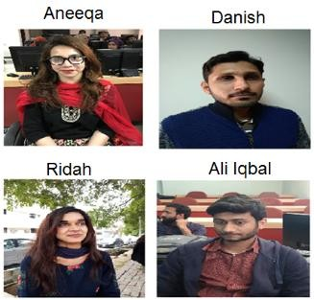

Fig. 1. Sample images of four subjects from the dataset.

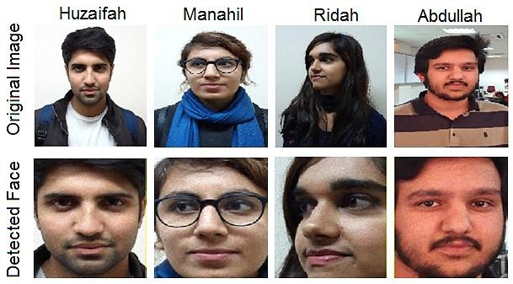

Fig. 2. Face detection using Voila-Jones algorithm.

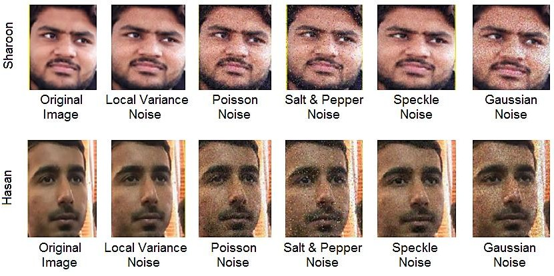

Fig. 3. Noisy versions of two example images from the dataset.

1. *Face Recognition*

The proposed systems uses a trained CNN for face classification. A typical CNN architecture comprises several layers of processing. The input layer specifies the size of input image, representing the height, width and channel size. The convolution layer performs feature extraction using 2D convolutions with several filters of a specific size. The batch normalization layer scales and adjust the activations to speeds up learning and reduce over-fitting. The pooling layer performs

downsampling by decreasing the size of feature maps and reduce redundant information. The fully connected layer identifies the pattern by gathering the features which are learned in previous layers. The last fully connected layer decides the output size which is equal to number of classes in the dataset. The softmax layer converts the activations from the last fully connected layer to classification probabilities, which are used by the classification layer for assigning the input to one of the mutually exclusive classes [31] [32] [33].

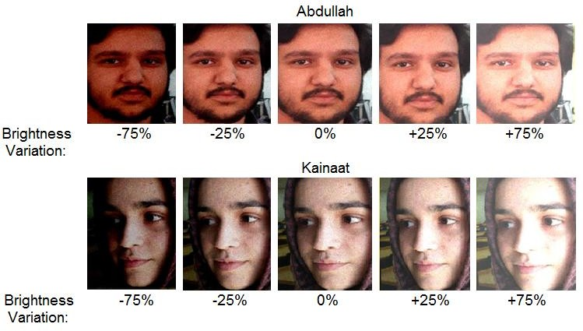

Fig. 4. Altered brightness versions of example images from the dataset

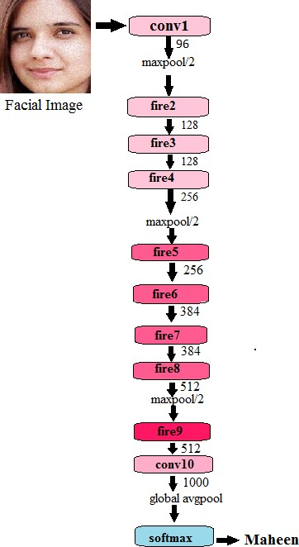

Fig. 5. SqueezeNet Architecture fine-tuned for face classification

Training a CNN is a computationally extensive and time consuming process. Transfer learning is usually used to speed up the training process. We tested five different pre-trained models with different architectures and different network complexities for selecting the optimum network for facial recognition. The pre-trained models are listed in Table I, along with the properties of each model which determine the computational complexity, i.e. network depth and train parameters. Squeezenet [34] was determined as the most

suitable network for face recognition in terms of computational cost and accuracy. The block diagram of Squeezenet architecture, fine-tuned for face classification using our dataset is shown in Figure 5. Selection of appropriate training options for CNN also plays a crucial role in the training process. The training options found suitable for the proposed method are shown in Table II.

TABLE I. PRE-TRAINED CNN MODELS

|  |  |  |  |
| --- | --- | --- | --- |
| **Model** | **Input Size** | **Network**  **Depth** | **Train**  **Parameters** |
| Alexnet | 227x227 | 8 | 61000000 |
| VGG16 | 224x224 | 16 | 138000000 |
| Squeezenet | 227x227 | 18 | 1240000 |
| Resnet18 | 224x224 | 18 | 11700000 |
| Resnet50 | 224x224 | 50 | 25600000 |

TABLE II. TRAINING OPTIONS FOR CNN

|  |  |
| --- | --- |
| **Parameter** | **Value** |
| Mini Batch Size | 10 |
| Max Epochs | 5 |
| Initial Learn Rate | 0.0001 |
| Optimizer | SGDM |
| Momentum | 0.9 |

1. EXPERIMENTAL RESULTS

This section presents the results obtained during experimentation and comparative analysis. The experiments are carried out in MATLAB R2018a on a computer with 64GB RAM and a 64-bit/2.3 GHz 18 core-processor. The deep neural networks were trained using an NVIDIA GPU with 12GB memory and compute capability of 3.5.

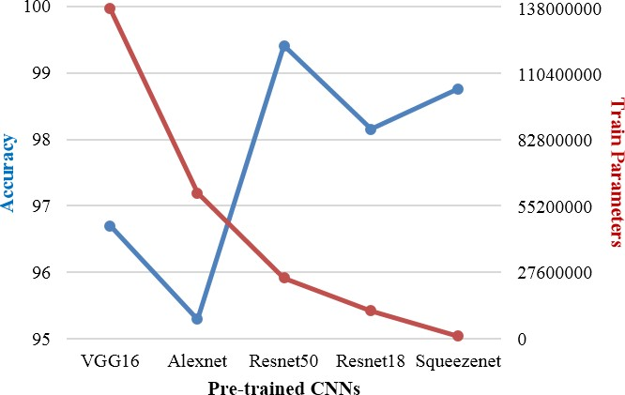

Fig. 6. Performance comparison of pre-trained CNNs

The augmented dataset containing 9000 images of 30 subjects is divided into training and testing sets for experimentation. 70% images are used for fine-tuning a pre- trained CNN model while the remaining 30% images are used for performance evaluation of the proposed method. The pre- trained CNNs presented in Table I are trained and tested one by one. Figure 6 shows the performance comparison of all five pre-trained CNNs in terms of accuracy and computational complexity (number of train parameters). The Squeezenet model, having the lowest computational cost represented by 1,240,000 training parameters, achieves the second highest accuracy of 98.76%. The Resnet50 model achieves the highest

accuracy of 99.41% but its layered architecture contains 20 times greater number of train parameters as compared to Squeezenet with accuracy improvement of only 0.65%. Therefore, the selection of Squeezenet for its use in the proposed face recognition system is a suitable trade-off between accuracy and computational cost.

The training accuracy and loss plots of the Squeezenet model, showing the training accuracy and loss values noted at every iteration during training, are presented in Figure 7. A smooth convergence to the optimal solution is noted during the training process. Figure 9 shows the confusion matrix obtained after testing the trained Squeezenet model on the test set. The confusion matrix shows the class-wise classification rates and an overall accuracy of 98.76%, which is very encouraging. The test images of all subjects are correctly classified as shown by the density of number of images at the diagonal, except a very few misclassifications.

The proposed biometric system based on deep face recognition takes an image of a subject or a group of subjects in a scene as input, detects faces using Viola Jones algorithm and then classifies each cropped facial part using a trained



for example, content based data retrieval, automated attendance management systems, web search by image, surveillance and social media applications. The promising results obtained in the experimental analysis depict the effectiveness of deep transfer learning in facial recognition for biometric authentication.

1. CONCLUSION

Facial recognition is gaining much importance and proving to be fruitful in many applications including biometric authentication, content based data retrieval, video surveillance, access control and social media. Face recognition is not user- dependent during operation and it is much faster as compared to other biometric systems. With the advent of big data and graphical computing, deep learning has impressively advanced the traditional computer vision systems over the past decade. In this direction, we have presented a CNN based face recognition system which automatically extracts facial features from faces detected using Viola Jones face detector for face recognition. A large database containing 9000 facial images of 30 subjects was created for training and testing. Encouraging experimental results showing an accuracy of 98.76% depict the effectiveness of deep face recognition for biometric authentication and

|  |  |  |  |  |  |  |  |  |  |  |  |  |  |  |  |  |  |  |  |  |  |  |  |  |  |  |  |  |  |
| --- | --- | --- | --- | --- | --- | --- | --- | --- | --- | --- | --- | --- | --- | --- | --- | --- | --- | --- | --- | --- | --- | --- | --- | --- | --- | --- | --- | --- | --- |
|  |  |  |  |  |  |  |  |  |  |  |  |  |  |  |  |  |  |  |  |  |  |  |  |  |  |  |  |  |  |
|  |  |  |  |  |  |  |  |  |  |  |  |  |  |  |  |  |  |  |  |  |  |  |  |  |  |  |  |  |  |
|  |  |  |  |  |  |  |  |  |  |  |  |  |  |  |  |  |  |  |  |  |  |  |  |  |  |  |  |  |  |
|  |  |  |  |  |  |  |  |  |  |  |  |  |  |  |  |  |  |  |  |  |  |  |  |  |  |  |  |  |  |
|  |  |  |  |  |  |  |  |  |  |  |  |  |  |  |  |  |  |  |  |  |  |  |  |  |  |  |  |  |  |
|  |  |  |  |  |  |  |  |  |  |  |  |  |  |  |  |  |  |  |  |  |  |  |  |  |  |  |  |  |  |
|  |  |  |  |  |  |  |  |  |  |  |  |  |  |  |  |  |  |  |  |  |  |  |  |  |  |  |  |  |  |
|  |  |  |  |  |  |  |  |  |  |  |  |  |  |  |  |  |  |  |  |  |  |  |  |  |  |  |  |  |  |
|  |  |  |  |  |  |  |  |  |  |  |  |  |  |  |  |  |  |  |  |  |  |  |  |  |  |  |  |  |  |
|  |  |  |  |  |  |  |  |  |  |  |  |  |  |  |  |  |  |  |  |  |  |  |  |  |  |  |  |  |  |
|  |  |  |  |  |  |  |  |  |  |  |  |  |  |  |  |  |  |  |  |  |  |  |  |  |  |  |  |  |  |
|  |  |  |  |  |  |  |  |  |  |  |  |  |  |  |  |  |  |  |  |  |  |  |  |  |  |  |  |  |  |
|  |  |  |  |  |  |  |  |  |  |  |  |  |  |  |  |  |  |  |  |  |  |  |  |  |  |  |  |  |  |
|  |  |  |  |  |  |  |  |  |  |  |  |  |  |  |  |  |  |  |  |  |  |  |  |  |  |  |  |  |  |
|  |  |  |  |  |  |  |  |  |  |  |  |  |  |  |  |  |  |  |  |  |  |  |  |  |  |  |  |  |  |
|  |  |  |  |  |  |  |  |  |  |  |  |  |  |  |  |  |  |  |  |  |  |  |  |  |  |  |  |  |  |
|  |  |  |  |  |  |  |  |  |  |  |  |  |  |  |  |  |  |  |  |  |  |  |  |  |  |  |  |  |  |
|  |  |  |  |  |  |  |  |  |  |  |  |  |  |  |  |  |  |  |  |  |  |  |  |  |  |  |  |  |  |
|  |  |  |  |  |  |  |  |  |  |  |  |  |  |  |  |  |  |  |  |  |  |  |  |  |  |  |  |  |  |
|  |  |  |  |  |  |  |  |  |  |  |  |  |  |  |  |  |  |  |  |  |  |  |  |  |  |  |  |  |  |
|  |  |  |  |  |  |  |  |  |  |  |  |  |  |  |  |  |  |  |  |  |  |  |  |  |  |  |  |  |  |
|  |  |  |  |  |  |  |  |  |  |  |  |  |  |  |  |  |  |  |  |  |  |  |  |  |  |  |  |  |  |
|  |  |  |  |  |  |  |  |  |  |  |  |  |  |  |  |  |  |  |  |  |  |  |  |  |  |  |  |  |  |
|  |  |  |  |  |  |  |  |  |  |  |  |  |  |  |  |  |  |  |  |  |  |  |  |  |  |  |  |  |  |
|  |  |  |  |  |  |  |  |  |  |  |  |  |  |  |  |  |  |  |  |  |  |  |  |  |  |  |  |  |  |
|  |  |  |  |  |  |  |  |  |  |  |  |  |  |  |  |  |  |  |  |  |  |  |  |  |  |  |  |  |  |
|  |  |  |  |  |  |  |  |  |  |  |  |  |  |  |  |  |  |  |  |  |  |  |  |  |  |  |  |  |  |
|  |  |  |  |  |  |  |  |  |  |  |  |  |  |  |  |  |  |  |  |  |  |  |  |  |  |  |  |  |  |
|  |  |  |  |  |  |  |  |  |  |  |  |  |  |  |  |  |  |  |  |  |  |  |  |  |  |  |  |  |  |
|  |  |  |  |  |  |  |  |  |  |  |  |  |  |  |  |  |  |  |  |  |  |  |  |  |  |  |  |  |  |



Fig. 9. Confusion matrix of the proposed system showing 98.76% overall clasification rate on the test-set

Squeezenet model. This process is illustrated in Figure 8 for two subjects. Automated and quick recognition of authorized persons in a restricted area using the proposed system can ensure hustle-free and secure access. Moreover, recognition of a suspect in smart city video streams captured in public areas can be promptly reported to the concerned authority for a quick action. Similarly, the proposed method can be tailored for its use in any applications where facial recognition is the first step,

identification systems. The proposed system can be used in a wide variety of applications including content based data retrieval, web search by image, surveillance, criminal identification, automated attendance systems and auto- enforcement of restricted access to certain areas.

ACKNOWLEDGEMENT

We are thankful to the Modeling & Simulation Lab, Institute of Space Technology for providing computational

resources for training the CNN models. We appreciate the cooperation of students of batch EE-14, Electrical Engineering Department, Institute of Space Technology in providing their photos for this research project.

REFERENCES

1. N. Hazim Barnouti, S. Sameer Mahmood Al-Dabbagh, and W. Esam Matti, “Face Recognition: A Literature Review,” *Int. J. Appl. Inf. Syst.*, vol. 11, no. 4, pp. 21–31ov 2016.
2. P. Savitra, J. Padwal, J. Chaitali, M. Surabhi Nilangekar, and U. K. Bodke J, “Automated Attendance System in College Using Face Recognition and NFC,” *Int. J. Comput. Sci. Mob. Comput.*, vol. 6, no. 6, pp. 14–21, 2017.
3. S. Aly and M. Hassaballah, “Face recognition: challenges, achievements and future directions,” *IET Comput. Vis.*, vol. 9, no. 4, pp. 614–626, 2015.
4. P. Liu *et al.*, “The false-positive and false-negative predictive value of HIV antibody test in the Chinese population,” *J. Med. Screen.*, vol. 15, no. 2, pp. 72–75, 2008.
5. Trigueros D S, Meng L and Hartnett M 2018 Face Recognition: From Traditional to Deep Learning Methods
6. R. T. Schirrmeister *et al.*, “Deep learning with convolutional neural networks for EEG decoding and visualization.,” *Hum. Brain Mapp.*, vol. 38, no. 11, pp. 5391–5420, 2017.
7. S. Kumar, S. Singh, and J. Kumar, “A study on face recognition techniques with age and gender classification,” *Proceeding - IEEE Int. Conf. Comput. Commun. Autom. ICCCA 2017*, vol. 2017-January, no. May, pp. 1001–1006, 2017.
8. R. Sharma and M. S. Patterh, “Face Recognition using Face Alignment and PCA Techniques: A Literature Survey,” *IOSR J. Comput. Eng. Ver. III*, vol. 17, no. 4, pp. 2278–661, 2015.
9. H. Yu and H. Liu, “Combining appearance and geometric features for facial expression recognition,” *Sixth Int. Conf. Graph. Image Process. (ICGIP 2014)*, vol. 9443, p. 944308, 2015.
10. S. Tseng, “Comparison of Holistic and Feature Based Approached to Face Recognition,” no. July, 2003.
11. Lata P Y V, Kiran C, Tungathurthi B, Rao H R M, Govardhan A and Reddy L P 2009 03_Facial Recognition using Eigenfaces by PCA *Int. J.*

*Recent Trends Eng.***1** 587–90

1. J. S. Bedre and S. Sapkal, “Comparative Study of Face Recognition Techniques:A Review,” *IJCA Proc. Emerg. Trends Comput. Sci. Inf. Technol. (ETCSIT2012)etcsit1001*, vol. ETCSIT, no. 1, pp. 12–15, 2012.
2. Lee H, Lee W and Chung J 2018 Face Recognition Using Fisherface Algorithm 998–1001
3. Belhumeur P, Hespanha J and Kriegman D 1997 Face recognition: Eigenfaces vs. Fish-erfaces: Recognition using class specific projection *IEEE Trans. Pattern Anal. Mach. Intell.***19** 711–20
4. BEHAM M P and ROOMI S M M 2013 a Review of Face Recognition Methods *Int. J. Pattern Recognit. Artif. Intell.***27** 1356005
5. Czarnowski I, Caballero A M, Howlett R J and Jain L C 2016 Smart Innovation, Systems and Technologies *Smart Innov. Syst. Technol.***56** 471
6. E. SADEGHIPOUR and N. SAHRAGARD, “Face Recognition Based on Improved SIFT Algorithm,” *Int. J. Adv. Comput. Sci. Appl.*, vol. 7, no. 1, pp. 548–551, 2016.
7. Bay H, Ess A, Tuytelaars T and Vangool L 2008 Speeded-Up Robust Features (SURF) (Cited by: 2272) *Comput. Vis. Image Underst.***110** 346–59
8. E. SADEGHIPOUR and N. SAHRAGARD, “Face Recognition Based on Improved SIFT Algorithm,” *Int. J. Adv. Comput. Sci. Appl.*, vol. 7, no. 1, pp. 548–551, 2016.
9. Kodinariya T M 2014 Hybrid Approach to Face Recognition System using Principle component and Independent component with score based fusion process
10. Jaber A K and Abdel-Qader I 2017 A Hybrid Feature Extraction Framework for Face Recognition *Int. J. Handheld Comput. Res.***8**1–13
11. A. Sharma and S. Chhabra, “A Hybrid Feature Extraction Technique for Face Recognition,” *Int. J. Adv. Res. Comput. Sci. Softw. Eng.*, vol. 7, no. 5, pp. 341–350, 2017.
12. Arsenovic M, Sladojevic S, Anderla A and Stefanovic D 2017 FaceTime—Deep learning based face recognition attendance system

*Intelligent Systems and Informatics (SISY), 2017 IEEE 15th International Symposium on* pp 53–8

1. M. J. Khan, A. Yousaf, A. Abbas, and K. Khurshid, “Deep learning for automated forgery detection in hyperspectral document images,” *J. Electron. Imaging*, vol. 27, no. 05, p. 1, Sep. 2018.
2. A. Carrio, C. Sampedro, A. Rodriguez-Ramos, and P. Campoy, “A Review of Deep Learning Methods and Applications for Unmanned Aerial Vehicles,” *J. Sensors*, vol. 2017, pp. 1–13, 2017.
3. J. Gu *et al.*, “Recent advances in convolutional neural networks,”

*Pattern Recognit.*, vol. 77, no. December 2015, pp. 354–377, 2018.

1. Q. Zhang, M. Zhang, T. Chen, Z. Sun, Y. Ma, and B. Yu, “Recent advances in convolutional neural network acceleration,” *Neurocomputing*, vol. 323, no. 61176031, pp. 37–51, 2019.
2. Fu R, Wang D, Li D and Luo Z 2017 University classroom attendance based on deep learning *Intelligent Computation Technology and Automation (ICICTA), 2017 10th International Conference on* pp 128– 31.
3. Y.-Q. J. I. P. O. L. Wang, "An analysis of the Viola-Jones face detection algorithm," vol. 4, pp. 128-148, 2014.
4. A. Gupta, R. J. I. J. o. R. R. i. M. C. S. Tiwari, and I. Technology, "Face detection using modified Viola jones algorithm," vol. 1, no. 2, pp. 59-66, 2015.
5. P. Arena, L. Fortuna, M. Frasca, G. J. I. J. o. B. Vagliasindi, and Chaos, "A wave-based CNN generator for the control and actuation of a lamprey-like robot," vol. 16, no. 01, pp. 39-46, 2006.
6. R. Arandjelovic, P. Gronat, A. Torii, T. Pajdla, and J. Sivic, "NetVLAD: CNN architecture for weakly supervised place recognition," in *Proceedings of the IEEE Conference on Computer Vision and Pattern Recognition*, 2016, pp. 5297-5307.
7. S. Agrawal and P. Khatri, "Facial expression detection techniques: based on Viola and Jones algorithm and principal component analysis," in *2015 Fifth International Conference on Advanced Computing & Communication Technologies*, 2015, pp. 108-112: IEEE.
8. F. N. Iandola, S. Han, M. W. Moskewicz, K. Ashraf, W. J. Dally, and K.

J. a. p. a. Keutzer, "SqueezeNet: AlexNet-level accuracy with 50x fewer parameters and< 0.5 MB model size," 2016.

1. M. J. Khan, H. S. Khan, A. Yousaf, K. Khurshid, and A. Abbas, “Modern Trends in Hyperspectral Image Analysis: A Review,” *IEEE Access*, vol. 6, no. 1, pp. 14118–14129, 2018.
2. M. J. Khan, A. Yousaf, K. Khurshid, A. Abbas, and F. Shafait, “Automated Forgery Detection in Multispectral Document Images using Fuzzy Clustering,” in *13th IAPR International Workshop on Document Analysis Systems*, 2018.
3. K. Khurshid, C. Faure, N. Vincent, “Word Spotting in Historical Printed Documents using Shape and Sequence Comparisons,” Pattern Recognition, 45(7): 2598-2609, 2012
4. K. Khurshid, C. Faure, N. Vincent, “Novel approach for word spotting using merge-split Edit distance,” Lecture Notes in Computer Science, 5702(1): 213-220, 2009.
5. K. Iqbal, K. Khurshid, “Automatic Signature Extraction from Document Images using Hyperspectral Unmixing,” Proceedings of the Pakistan Academy of Sciences, 54(3): 257-265, 2017.
6. M. J. Khan, A. Yousaf, N. Javed, S. Nadeem, and K. Khurshid, “Automatic Target Detection in Satellite Images using Deep Learning,” *J. Sp. Technol.*, vol. 7, no. 1, pp. 44–49, 2017.
7. M. J. Khan, K. Khurshid, and F. Shafait, “A Spatio-Spectral Hybrid Convolutional Architecture for Hyperspectral Document Authentication,” in *2019 15th IAPR International Conference on Document Analysis and Recognition (ICDAR)*, Sydney, Australia, 2019.
8. A. Yousaf et al., "Size Invariant Handwritten Character Recognition using Single Layer Feedforward Backpropagation Neural Networks," *2019 2nd International Conference on Computing, Mathematics and Engineering Technologies (iCoMET)*, Sukkur, Pakistan, 2019, pp. 1-7.
9. M. J. Khan, N. Said, A. Khan, N. Rehman and K. Khurshid, "Automated Latin Text Detection in Document Images and Natural Scene Images based on Connected Component Analysis," *2019 2nd International Conference on Computing, Mathematics and Engineering Technologies (iCoMET)*, Sukkur, Pakistan, 2019, pp. 1-6.
10. M. S. Saleem, M. J. Khan, K. Khurshid, M. S. Hanif, “Crowd density estimation in still images using multiple local features and boosting regression ensemble”, *Neural Computing & Applications*, 2019, pp. 1- 10.